**Project Report**

**on**

**“Accurate Prediction of Sepsis in ICU Patients”**

Submitted to the

Savitribai Phule Pune University

In partial fulfillment for the award of the Degree of

Bachelor of Engineering

in

Information Technology

by

72147941D: - Sneha Bamane

72147968F: - Akansha Chandle

72148044G: - Shweta Maharanawar

72148076E: - Devyani Pathrikar

Under the guidance of

**Prof. M. A. Rane**



Department of Information Technology

Bharati Vidyapeeth's College of Engineering for Women

Katraj-Dhankawadi,

Pune - 411 043.

**2023-24**



**CERTIFICATE**

**Department of Information Technology**

This is to certify that,

72147941D: - Sneha Bamane

72147968F: - Akansha Chandle

72148044G: - Shweta Maharanawar

72148076E: - Devyani Pathrikar

have successfully completed this project report entitled **“Accurate Prediction of Sepsis in ICU Patients”,** under my guidance in partial fulfilment of the requirements for the degree of Bachelor of Engineering in the Department of Information Technology of Savitribai Phule Pune University during the academic year 2023-24.

Date:

Place: Pune

|  |  |  |
| --- | --- | --- |
| Prof. M. A. Rane of Guide |  | Prof. Dr. D. A. Godse |
|  |  | Head of the Department |
|  |  |  |
|  | Prof. Dr. S. R. Patil |  |
|  | Principal |  |

This project report is examined by us as per the Savitribai Phule Pune University, Pune requirements at Bharati Vidyapeeth's College of Engineering for Women, Pune - 43 on ____________

Internal Examiner External Examiner

**ACKNOWLEDGEMENT**

We take this opportunity to thank our project guide Prof. M. A.s Rane, review panel member Prof. S. A. Hadke, Head of Department of Information Technology Prof. Dr. D. A. Godse for their valuable guidance and for providing all the necessary facilities, which were indispensable in the completion of this project report. We are also grateful to respected Prof. Dr S. R. Patil, Principal, Bharati Vidyapeeth’s College of Engineering for Women, Pune, for his support and guidance that has helped to expand the horizons of thought and expression. We would also like to thank the institute for providing the required facilities, Internet access and important books.

Sneha Bamane

Akansha Chandle

Shweta Maharanawar

Devyani Pathrikar

**ABSTRACT**

The "Accurate Prediction of Sepsis in ICU Patients" project is a multifaceted initiative that combines awareness and predictive modeling to address sepsis, a life-threatening condition commonly encountered in intensive care units (ICUs).

Central to this project is a robust awareness campaign designed to educate both the general public and healthcare professionals about sepsis. With a focus on raising awareness about the severity of sepsis and the pivotal role of early detection and intervention, this educational effort seeks to empower individuals to recognize sepsis symptoms and promptly seek medical attention.

Concurrently, advanced machine learning techniques, specifically logistic regression algorithms, are employed to construct a predictive model for sepsis. This model undergoes meticulous fine-tuning to ensure accurate identification of sepsis risk in ICU patients.

The data-driven approach encompasses comprehensive data preprocessing and addresses class imbalances in the dataset. The integration of the Sequential Organ Failure Assessment (SOFA) score, including the quick SOFA (qSOFA) criteria, enhances predictive accuracy by evaluating organ failure trajectories and risk factors. The qSOFA criteria play a crucial role in rapid risk assessment, especially concerning sepsis, allowing for swift interventions that can be life-saving.

Moreover, the project maintains a dedicated website that serves as an essential platform for sepsis education and the dissemination of the predictive model to the medical community. This digital platform not only underscores the commitment to raising awareness but also facilitates the integration of advanced technologies into healthcare practices.

In summary, project endeavors to create sepsis awareness, enhance predictive capabilities, and support healthcare professionals and the general public in their fight against sepsis. This multifaceted initiative, deeply rooted in education, data-driven technologies, and clinical acumen, aims to contribute to a healthier and more informed future.

**CONTENTS**

|  |  |
| --- | --- |
| Acknowledgement | III |
| Abstract | IV |
| List of Abbreviations | V |
| List of Figures | VI |
| List of Graphs | VII |
| List of Tables | VIII |

|  |  |  |  |  |
| --- | --- | --- | --- | --- |
| **Sr. No.** | | **Chapter** | | **Page No.** |
| **1.** |  | **Introduction to Project** | | 1-5 |
|  | 1.1 | Introduction to Project | | 1-2 |
|  | 1.2 | Aims / Motivation behind Project | | 2 |
|  | 1.3 | Overview of the Project | | 3 |
|  | 1.4 | Need of the Project | | 3-4 |
|  | 1.5 | Organization of the report | | 4-5 |
| **2.** |  | **Literature Survey** | | 6-8 |
|  | 2.1 | Introduction | | 6 |
|  | 2.2 | Related Work | | 6-8 |
| **3.** |  | **Problem Statement** | | 9-11 |
|  | 3.1 | Features of the Project | | 9-10 |
|  | 3.2 | Scope of the Project | | 10 |
|  | 3.3 | Objectives of the Project | | 10 |
|  | 3.4 | Constraints of the Project | | 10-11 |
| **4.** |  | **Project Requirements** | | 12-13 |
|  | 4.1 | H/W and S/W Requirements | | 13 |
| **5.** |  | **System Analysis of Proposed Architecture** | | 14-21 |
|  | 5.1 | Flowchart / Proposed System Architecture | | 14-16 |
|  | 5.2 | High Level Design of the Project | | 16-21 |
|  |  | 5.2.2 | Data Flow Diagrams up to Level 2 | 16-18 |
|  |  | 5.2.3 | UML Diagrams: Use Case, Class Diagram, Activity Diagram … | 19-21 |
| **6.** |  | **System Implementation** | | 22-24 |
|  | 6.1 | Algorithm Style | | 22 |
|  | 6.2 | Description of Detailed Methodologies | | 23-24 |
| **7.** |  | **Test Cases** | | 25 |
| **8.** |  | **Proposed GUI/Working modules/Experimental Results** | | 26-29 |
| **9.** |  | **Project Plan** | | 30-31 |
| **10**. |  | **Conclusion** | | 32 |
|  |  | **Bibliography in IEEE format** | | 33 |
|  |  | **Appendices** | | 34 |
|  | **A.** | Plagiarism Report of Paper and Project report from any open-source tool. | |  |
|  | **B.** | Base Paper(s) | |  |
|  | **C.** | Tools used / Hardware Components specifications. | |  |
|  | **D.** | Published Papers and Certificates. | |  |

**LIST OF ABBREVIATIONS**

1. AAA – Authentication Authorization, Accounting
2. ACK- Acknowledgement
3. ALU- Arithmetic and Logical Unit
4. BASIC - Beginners All-Purpose Symbolic Instruction Code
5. ML - Machine Learning
6. SOFA - Sequential Organ Failure Assessment
7. qSOFA - Quick Sequential Organ Failure Assessment

**LIST OF FIGURES**

|  |  |  |
| --- | --- | --- |
| **Sr. No.** | **Figure Name** | **Page No.** |
| **1.1** | **Agile Development Model** | **3** |
| **5.1** | **Proposed System Architecture** | **14** |
| **5.2** | **Level 0 DFD** | **16** |
| **5.3** | **Level 1 DFD** | **17** |
| **5.4** | **Level 2 DFD** | **18** |
| **5.5** | **Use Case Diagram** | **19** |
| **5.6** | **Class Diagram** | **20** |
| **5.7** | **Activity Diagram** | **21** |

**LIST OF TABLES**

|  |  |  |
| --- | --- | --- |
| **Sr. No.** | **Table Name** | **Page No.** |
| **7.1** | **Test case** | **25** |
|  |  |  |
|  |  |  |
|  |  |  |
|  |  |  |

**CHAPTER 1**

**INTRODUCTION TO PROJECT**

* 1. **Introduction to Project**

Sepsis, a life-threatening condition triggered by infections, remains a critical concern within the realm of intensive care units (ICUs). In response to this issue, we present the " Accurate Prediction of Sepsis in ICU Patients" project. This initiative is driven by a dual commitment: raising awareness about sepsis and harnessing the power of predictive modeling to revolutionize patient care within ICUs.

At its core, prioritizes education and awareness. Our efforts extend to both the general public and healthcare professionals, as we recognize the significance of knowledge in the battle against sepsis. By raising awareness about the gravity of sepsis and the paramount importance of early detection and intervention, we aim to empower individuals to recognize its signs and seek immediate medical attention.

In parallel, the project leverages advanced machine learning techniques, specifically logistic regression algorithms, to construct a predictive model for sepsis. The model's rigorous fine-tuning is aimed at achieving accurate identification of sepsis risk in ICU patients. This predictive tool represents a critical advancement in healthcare, offering the potential for early interventions and improved patient outcomes.

Our data-driven approach encompasses comprehensive data preprocessing, addressing class imbalances within the dataset. Additionally, the integration of the Sequential Organ Failure Assessment (SOFA) score, including the quick SOFA (qSOFA) criteria, enhances predictive accuracy by evaluating organ failure trajectories and risk factors.

Moreover, the project maintains a dedicated website named “Avagat”, serving as an essential platform for sepsis education and the dissemination of the predictive model to the medical community.

* 1. **Aims/Motivation behind Project**

The driving force behind the Project can be distilled into a few key motivations:

1. **Sepsis Severity**: The project is motivated by the gravity of sepsis as a life-threatening condition, especially within intensive care units (ICUs). Recognizing the severity of sepsis fuels our commitment to addressing this critical issue.
2. **Early Detection**: Early detection and intervention are pivotal in sepsis management. We are motivated to raise awareness and create a predictive model to enable early sepsis identification, ultimately saving lives.
3. **Data-Driven Solutions**: We are driven by the belief in data-driven solutions. Leveraging advanced machine learning techniques, we seek to use data to enhance decision-making in healthcare.
4. **Patient-Centered Care**: Our core motivation is patient-centered care. We are dedicated to improving patient outcomes, reducing sepsis-related burdens, and contributing to a healthier future.
5. **Interdisciplinary Approach**: Recognizing the value of interdisciplinary methods, we are motivated to address sepsis comprehensively by combining education, technology, and clinical insights.
6. **Raising Awareness**: The first step in combating sepsis is awareness. We are motivated to spread knowledge about sepsis, ensuring both the public and healthcare professionals are equipped to recognize and respond to this condition.
7. **Reducing Tragedies**: Our ultimate motivation is to reduce sepsis-related tragedies. The knowledge that sepsis is a leading cause of mortality in ICUs drives us to integrate clinical insights, including qSOFA, into our predictive model to make a tangible difference.
   1. **Overview of the Project**

Our Project is executed following an Agile software development model. This model ensures flexibility, adaptability, and a continuous improvement approach. The project unfolds through iterative cycles, allowing for regular feedback and enhancements. Each cycle includes phases of requirement gathering, system design, implementation, testing, and deployment. Data preprocessing and modeling are central components, with logistic regression algorithms driving predictive capabilities. Integration of the Sequential Organ Failure Assessment (SOFA) score, including qSOFA criteria, enhances accuracy. Additionally, the project maintains a dedicated website for sepsis education and predictive model dissemination. This approach enables the project to remain responsive to evolving needs, deliver incremental value, and align with its overarching goals effectively.

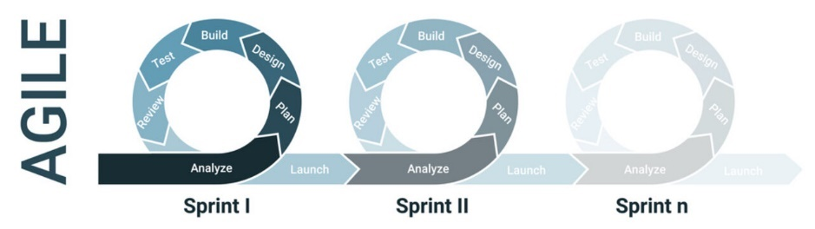

Fig.1.1 Agile software development model

* 1. **Need of the Project**

Our Project addresses a pressing need within the healthcare landscape. Sepsis, a life-threatening condition, demands swift identification and intervention, particularly in intensive care units (ICUs) where patients are most vulnerable. The significance of this study lies in its potential to revolutionize patient care by bridging critical gaps. By fostering sepsis awareness among both the public and healthcare professionals, the project empowers individuals to recognize symptoms early, ultimately saving lives. Furthermore, the development of an advanced predictive model for sepsis, integrated with the Sequential Organ Failure Assessment (SOFA) score and qSOFA criteria, ensures rapid and accurate risk assessment. This innovation enhances patient outcomes and contributes to the reduction of sepsis-related fatalities in ICUs. The project's profound impact extends beyond the boundaries of sepsis, serving as a model for the successful integration of education, data-driven technology, and clinical insights in healthcare. Ultimately, the significance of this study lies in its potential to create a healthier, more informed future, where sepsis-related tragedies are minimized, and the standards of patient care in ICUs are elevated.

* 1. **Organization of the Project Report**

1. **Introduction to Project:**
   * Provide an overview of the project, introducing the significance of early sepsis detection in the ICU setting and the purpose of the Project.
2. **Aims / Motivation behind Project:**
   * Explain the motivation for your project, which is to improve the accuracy of sepsis prediction using machine learning and enhance patient outcomes in ICUs.
3. **Overview of the Project:**
   * Outline the main components of the project, including the utilization of SOFA and qSOFA scores, machine learning algorithms, and the goal of achieving early sepsis detection.
4. **Need of the Project:**
   * Explore the reasons why accurate sepsis prediction in ICU patients is essential. Discuss the challenges and gaps in current sepsis detection methods that your project aims to address.
5. **Literature Survey (minimum five papers):**
   * Provide a literature review section that covers relevant academic and research papers. Discuss the background, related work, and the problem statement in the context of sepsis prediction.
6. **Features of the Project:**
   * Describe the core features of the project, focusing on the application of SOFA and qSOFA scores, machine learning models, and their integration into clinical practice.
7. **Scope of the Project:**
   * Define the boundaries of your project, clarifying what aspects of sepsis detection in ICUs are covered. This sets expectations for the reader.
8. **Objectives of the Project:**
   * List the specific goals and objectives of your project, highlighting what you intend to achieve with regard to sepsis prediction.
9. **Constraints of the Project:**
   * Address any limitations or constraints that may have influenced the development of the project, such as data availability or model performance.
10. **Project Requirements:**
    * Outline the hardware and software requirements necessary to implement and run project. This section explains what's needed for the platform to function effectively.
11. **System Analysis of Proposed Architecture:**
    * Delve into the technical aspects of your project, including system architecture, data flow diagrams, and any relevant UML diagrams. This provides a technical understanding of how the platform operates.
12. **System Implementation:**
    * Discuss the technical implementation of your sepsis prediction system, including the use of machine learning algorithms, data preprocessing, and the integration of SOFA and qSOFA scores.
13. **Project Plan:**
    * Present the project's timeline, milestones, and development plans. This section outlines how the project will be executed.
14. **Conclusion:**
    * Summarize the project's key takeaways, achievements, and its potential impact on improving sepsis detection in ICU patients. Reflect on the project's journey and outcomes.

**CHAPTER 2**

**LITERATURE SURVEY**

* 1. **Introduction**

This literature survey provides an overview of relevant research in the field of sepsis prediction, emphasizing the importance of early diagnosis and the application of machine learning techniques. By reviewing recent studies, we aim to establish a contextual framework for our project. These studies highlight the significance of predictive models, such as Random Forest, Logistic Regression, and Gradient Boosting, in predicting sepsis and in-hospital mortality. Through this literature survey, we aim to gain insights from existing work and inform the direction of our research.

* 1. **Related Work**

|  |  |  |  |
| --- | --- | --- | --- |
| **Title** | **Author** | **Publication** | **Remark** |
| Early Prediction of Sepsis using Machine Learning | Anurag Shankar, Mufaddal Diwan, Snigdha Singh, Husain Nahrpurawala and Tanusri Bhowmick | IEEE, 2021 | The paper introduces the importance of the SOFA score and the challenges in timely diagnosis, serving as a basis for our project. |
| A Comprehensive Machine Learning Based Pipeline for an Accurate Early Prediction of Sepsis in ICU | B. C. SRIMEDHA, RASHMI NAVEEN RAJ, AND VEENA MAYYA | IEEE Access, 2022 | This research by investigating four prediction algorithms, including Random Forest, Logistic Regression, Gradient Boosting, and Decision Tree, and examining the impact of various imputation techniques, |
| Using machine learning methods to predict in-hospital mortality of sepsis patients in the ICU | Guilan Kong, Ke Lin and Yonghua Hu | 2020, Published by  BMC. | This study focuses on leveraging machine learning techniques to predict the in-hospital mortality of sepsis patients in the ICU. Machine learning models, including the least absolute shrinkage and selection operator (LASSO), random forest (RF), gradient boosting machine (GBM), and traditional logistic regression (LR), were developed for prediction. |
| A Machine Learning Model for Early Prediction and Detection of Sepsis in Intensive Care Unit Patients | Yash Veer Singh, Pushpendra Singh, Shadab Khan, and Ram Sewak Singh | 2022, Published by Hindawi. | This paper introduces a machine learning model for early sepsis prediction in ICU patients, leveraging data from clinical laboratory values and vital signs. Various models, including SVM, RF, NB, LR, and XGBoost, are examined and compared, with the proposed ensemble method showing the most promising results in terms of classification performance and prognosis improvement. |
| Early Prediction of Mortality, Severity, and Length of Stay in the Intensive Care Unit of Sepsis Patients Based on Sepsis 3.0 by Machine Learning Models | Longxiang Su, Zheng Xu, Fengxiang Chang, Yingying Ma, Shengjun Liu, Huizhen Jiang, Hao Wang, Dongkai Li, Huan Chen, Xiang Zhou, Na Hong, Weiguo Zhu, and Yun Long | 28 June 2021, Published by Frontiers in Medicine | This study centers around harnessing machine learning techniques to anticipate in-hospital mortality among sepsis patients in the ICU. Several machine learning models were constructed for this purpose, encompassing the least absolute shrinkage and selection operator (LASSO), random forest (RF), gradient boosting machine (GBM), and the conventional logistic regression (LR). |

.

.

**CHAPTER 3**

**PROBLEM STATEMENT**

To develop a predictive model for early detection of sepsis in ICU patients and to create a website for generating a website for sepsis awareness containing information about sepsis.

**3.1 Features of the Project:**

* **Sepsis Awareness Campaign**: The project includes a dedicated website and educational resources to raise awareness about sepsis, its symptoms, and the importance of early detection.
* **Educational Content**: Informative materials simplify complex medical information, making it accessible to the general public and healthcare professionals, empowering them to recognize sepsis symptoms.
* **Advanced Predictive Modeling**: The project leverages logistic regression algorithms for the development of a predictive model that accurately identifies sepsis risk in ICU patients.
* **Integration of qSOFA Criteria**: The predictive model integrates the quick Sequential Organ Failure Assessment (qSOFA) criteria, enabling rapid risk assessment and intervention.
* **Data Preprocessing**: Comprehensive data preprocessing techniques are applied to address class imbalances in the dataset, enhancing the model's predictive accuracy.
* **Interdisciplinary Approach**: The project combines education, data-driven technology, and clinical insights, ensuring a holistic approach to sepsis management.
* **Digital Platform**: The project maintains a dedicated website as a central platform for sepsis education and the dissemination of the predictive model to the medical community.
* **Continuous Improvement**: An agile development model allows for flexibility and ongoing enhancements to meet evolving needs effectively.
* **Data-Driven Insights**: The project ensures that data-driven insights are used to inform clinical decisions and enhance early intervention strategies.

**3.2 Scope of the Project:**

The scope of our project encompasses creating awareness, implementing advanced predictive modeling for sepsis detection, and fostering a holistic approach to sepsis management. It aims to reduce sepsis-related mortality rates in ICUs, improve patient outcomes, and serve as a model for integrating education and technology in healthcare practices.

**3.3 Objectives of the Project:**

* To educate the public and healthcare professionals about sepsis, its severity, and the importance of early recognition.
* To develop and implement an advanced predictive model for sepsis to enable early detection and intervention in intensive care units (ICUs).
* To improve patient outcomes by minimizing sepsis-related fatalities through early intervention and rapid risk assessment.
* To utilize data-driven insights to inform clinical decisions and enhance the quality of patient care in ICUs.
* To combine education, technology, and clinical insights to create a holistic approach to sepsis management.
* To contribute to a reduction in the burden of sepsis by fostering proactive healthcare practices.
* To serve as a model for successfully integrating education and technology into healthcare practices, potentially impacting other critical medical conditions.

**3.4 Constraints of the Project:**

* **Data Availability**: The project relies on the availability of comprehensive and reliable healthcare data for the development of the predictive model, which can sometimes be limited.
* **Technological Infrastructure**: Access to suitable technological infrastructure and resources is crucial for implementing the predictive model and maintaining the project's digital platform.
* **Clinical Adoption**: The successful adoption of the predictive model within clinical settings may face resistance or challenges, requiring careful integration strategies.
* **Data Privacy and Ethics**: Adhering to data privacy and ethical considerations in healthcare data usage is a paramount constraint that demands rigorous compliance.

**CHAPTER 4**

**PROJECT REQUIREMENTS**

Project Requirements are as follows:

* **Data Set**: Access to a comprehensive healthcare data set, sourced from Kaggle, is crucial for the development and training of the predictive model.
* **Algorithm**: Implement the Logistic algorithm as the primary predictive model, ensuring its accuracy after thorough comparison with other models.
* **HTML and CSS**: Develop a user-friendly web interface using HTML and CSS to provide educational resources, awareness materials, and model access to users.
* **Flask Framework**: Utilize the Flask web framework to build the project's digital platform, integrating the educational content, predictive model, and awareness campaigns.
* **Database**: Set up a database to store and manage healthcare data required for the predictive model, ensuring data security, privacy, and efficient retrieval.
* **Technology Infrastructure**: Ensure access to the necessary technological infrastructure, including server resources, for hosting the project's website and predictive model.
* **Budget and Funding**: Secure adequate funding to sustain the project, covering the costs associated with awareness campaigns, server hosting, and development efforts.
* **Data Privacy and Ethics**: Adhere to stringent data privacy and ethical standards when handling sensitive healthcare data within the project.
* **Flexibility**: Maintain a flexible project approach to accommodate the evolving landscape of medical practices and technological advancements.

By fulfilling these requirements, the project can effectively bridge the gap in sepsis awareness and early detection while contributing to improved patient care in ICUs.

**4.1 Hardware and Software Requirements**

· **Hardware**

1. Computer(s)

2. System: Intel I7 or above

3. RAM: 4GB or above

· **Software**

1. Operating System: Windows 10 or any open source OS

2. Programming Languages: Python for machine learning, data development.

3. Development Tools: Visual Studio Code, Anaconda

· **Other equipment**

1. Internet Connection

2. Data Sources

**CHAPTER 5**

**SYSTEM ANALYSIS OF PROPOSED ARCHITECTURE**

**5.1 Proposed System Architecture**

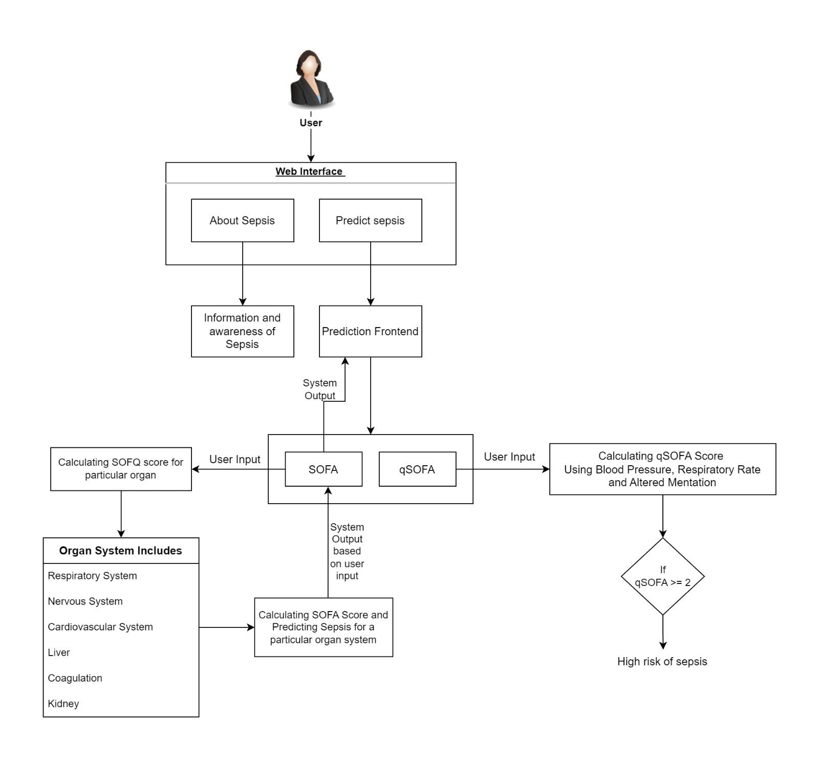

Fig 5.1 Proposed System Architecture

The system architecture for the **Accurate Prediction of Sepsis in ICU Patients** is designed to seamlessly integrate technology, education, and clinical insights to address the pressing issue of sepsis in intensive care units (ICUs).

**1. Input Data:**

* The architecture begins with the input data, which comprises a set of vital signs and clinical parameters from ICU patients. Specifically, we focus on:
  + Blood Pressure
  + Respiratory Rate
  + Altered Mentation

**2. SOFA Score Calculation:**

* The SOFA score is a comprehensive assessment that evaluates the patient's condition across various organ systems. This includes:
  + Respiratory System
  + Nervous System
  + Cardiovascular System
  + Liver
  + Coagulation
  + Kidney
* Machine learning algorithms are employed to calculate the SOFA score by considering the values of these organ systems. The resulting score provides an indication of the patient's overall health.

**3. qSOFA Score Calculation:**

* In contrast to SOFA, the qSOFA score is a more rapid assessment that focuses on three key criteria:
  + Blood Pressure
  + Respiratory Rate
  + Altered Mentation
* We use machine learning techniques to calculate the qSOFA score, enabling quick predictions of sepsis risk.

**4. Prediction Outcome:**

* Both the SOFA and qSOFA scores play a crucial role in our sepsis prediction. These scores are used as features to train machine learning models. The architecture integrates these scores with other clinical insights to enhance prediction accuracy.

**5. Machine Learning Algorithms:**

* While we use machine learning algorithms to calculate the scores, we also employ additional machine learning models for sepsis prediction. These models are fine-tuned for accuracy and will be chosen based on their performance. Future sections of the project report will provide detailed information on the specific machine learning algorithms used.

Our architecture allows us to leverage clinical data, vital signs, and organ system assessments to make informed predictions about a patient's risk of developing sepsis. By using SOFA and qSOFA scores as integral components, we ensure a comprehensive and timely approach to sepsis prediction in ICU patients.

Top of Form

**5.2 High Level Design of the Project**

**5.2.1 Data Flow Diagrams**

**Level 0 DFD**

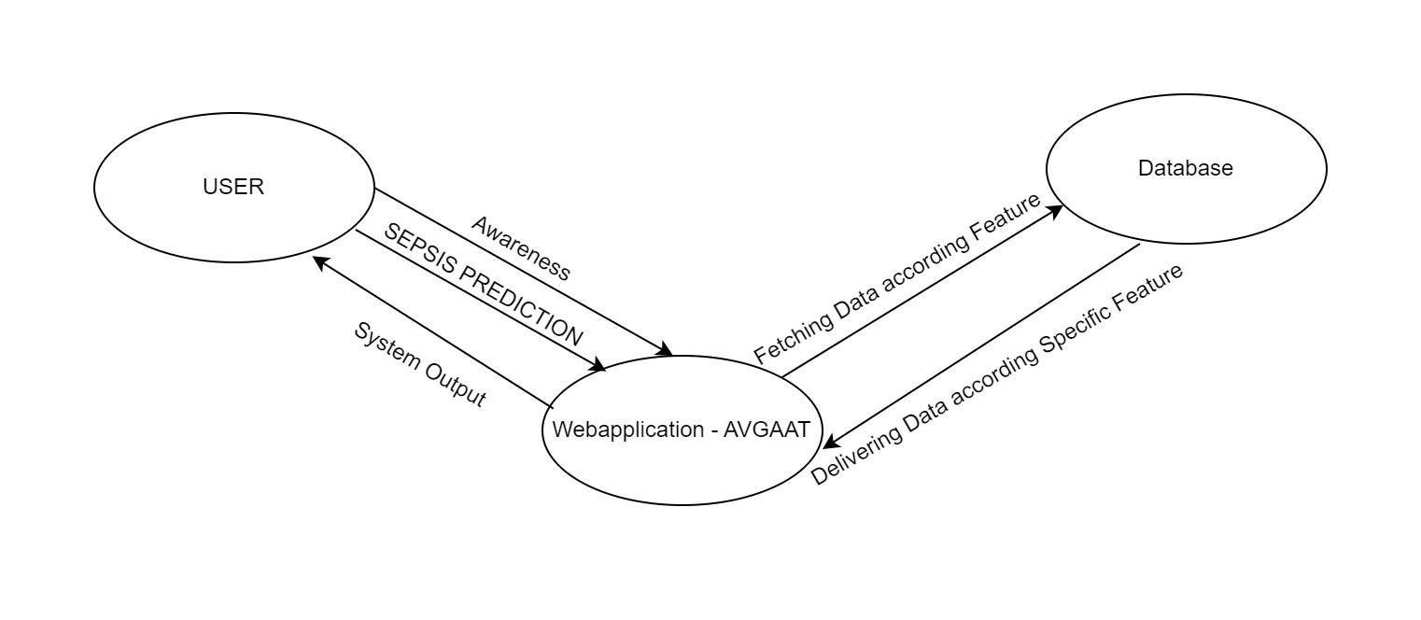

Fig 5.2 Level 0 DFD

**Level 1 DFD**

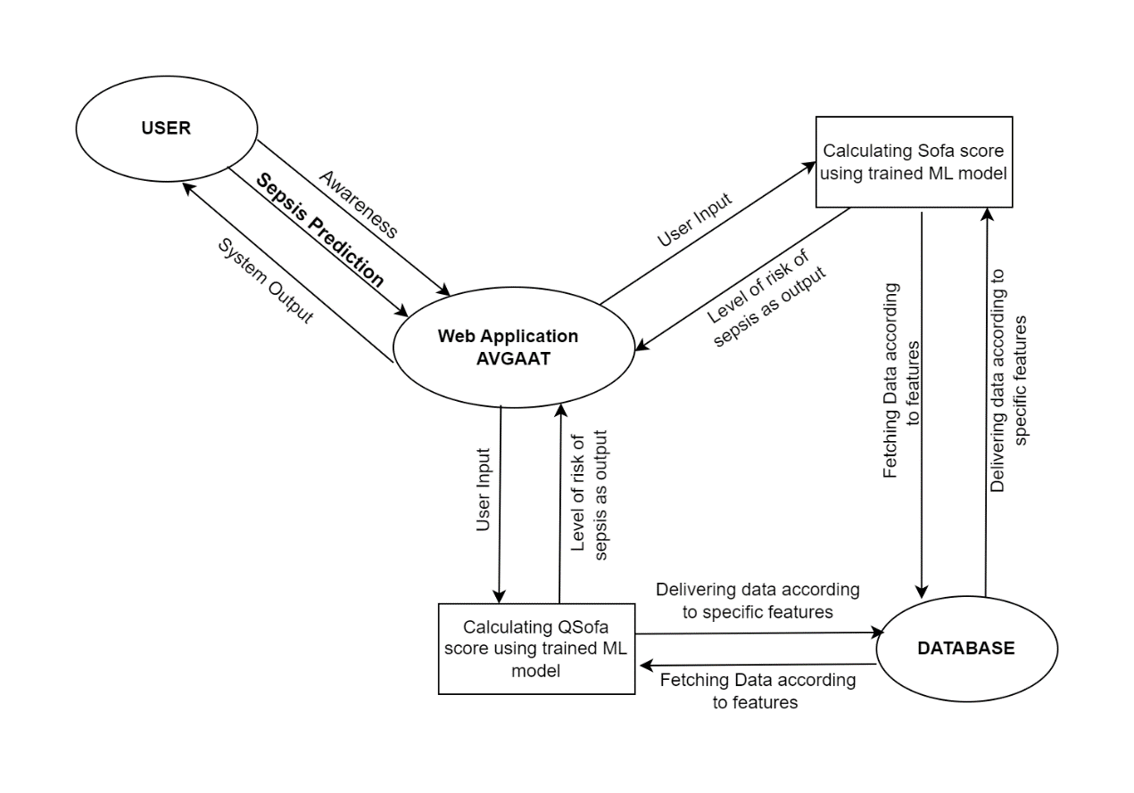

Fig 5.3 Level 1 DFD

**Level 2 DFD**

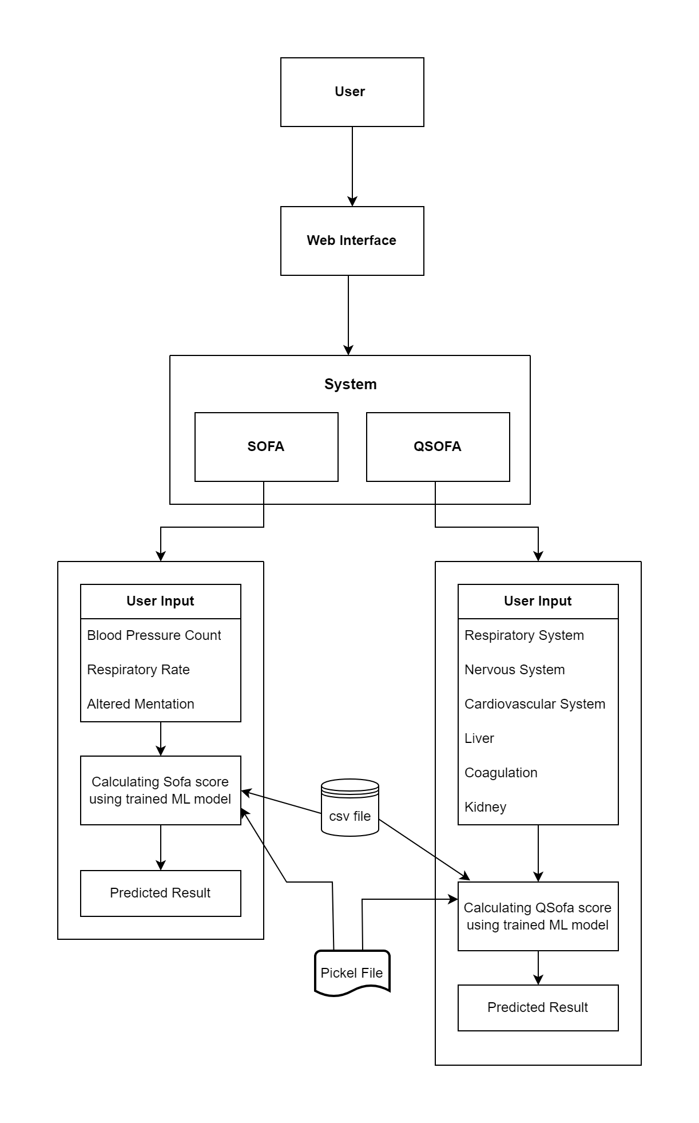

Fig 5.4 Level 2 DFD

**5.2.2 UML Diagrams**

**Use Case Diagram**

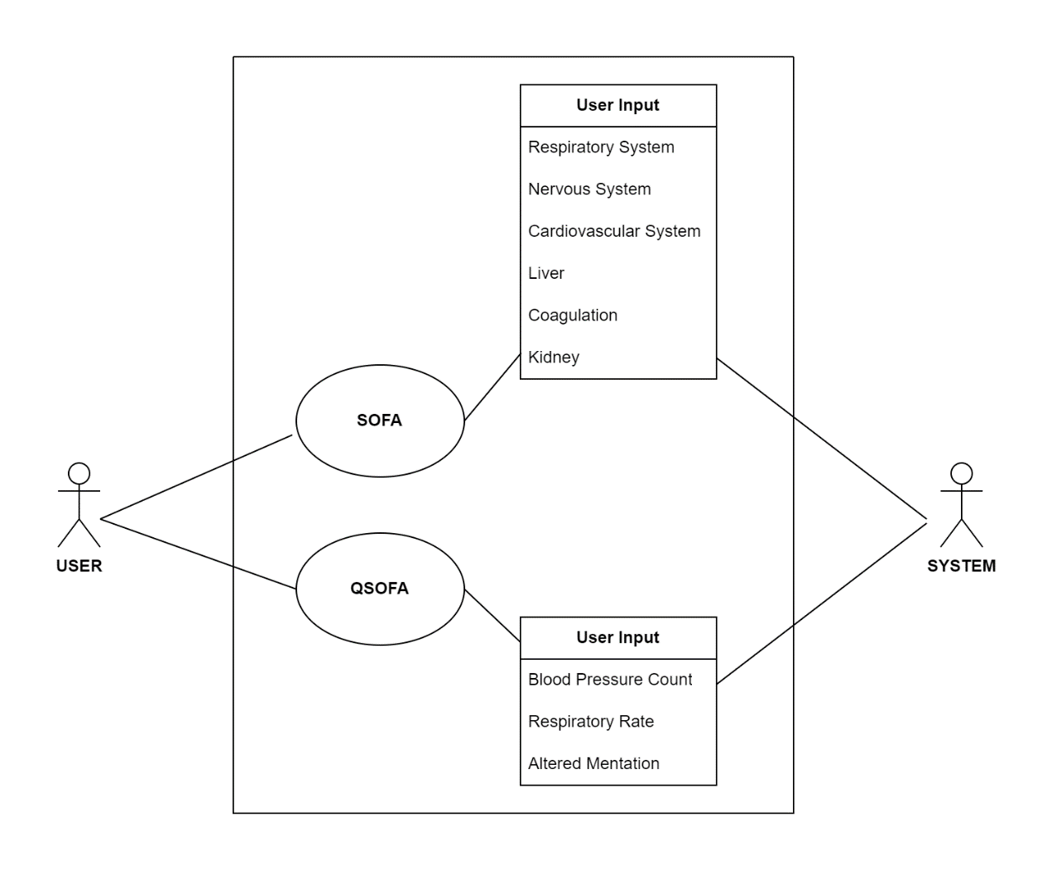

Fig 5.5 Use Case Diagram

**Class Diagram**

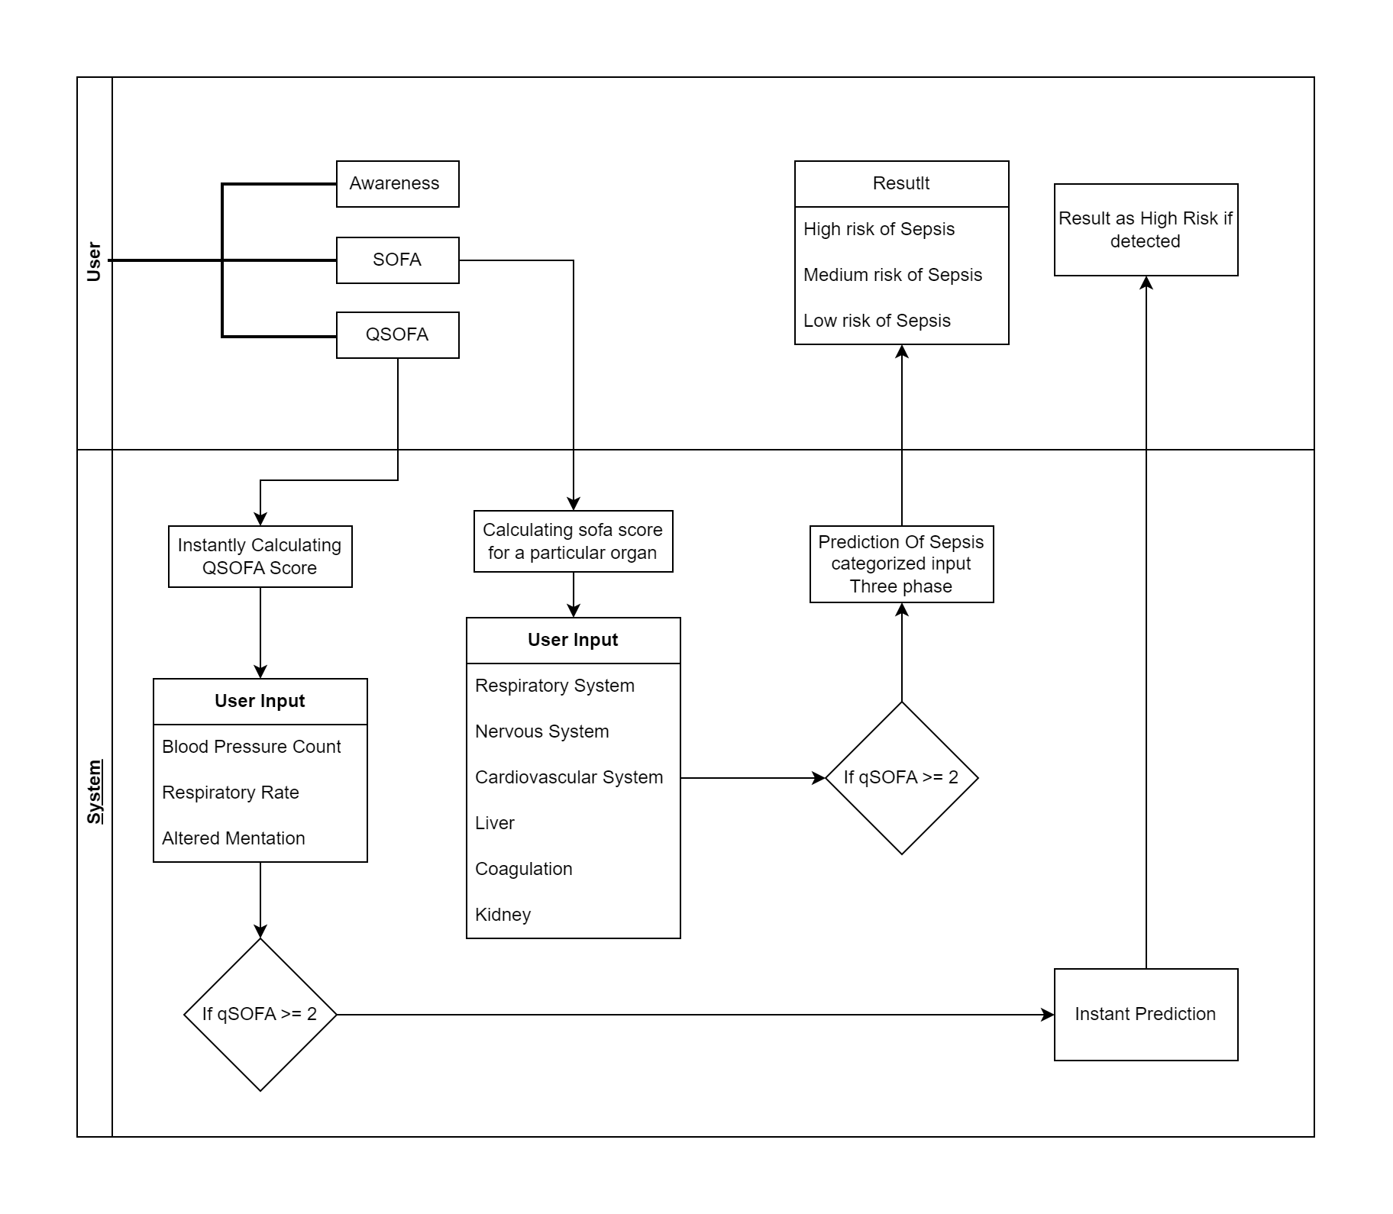

Fig 5.6 Class Diagram

**Activity Diagram**

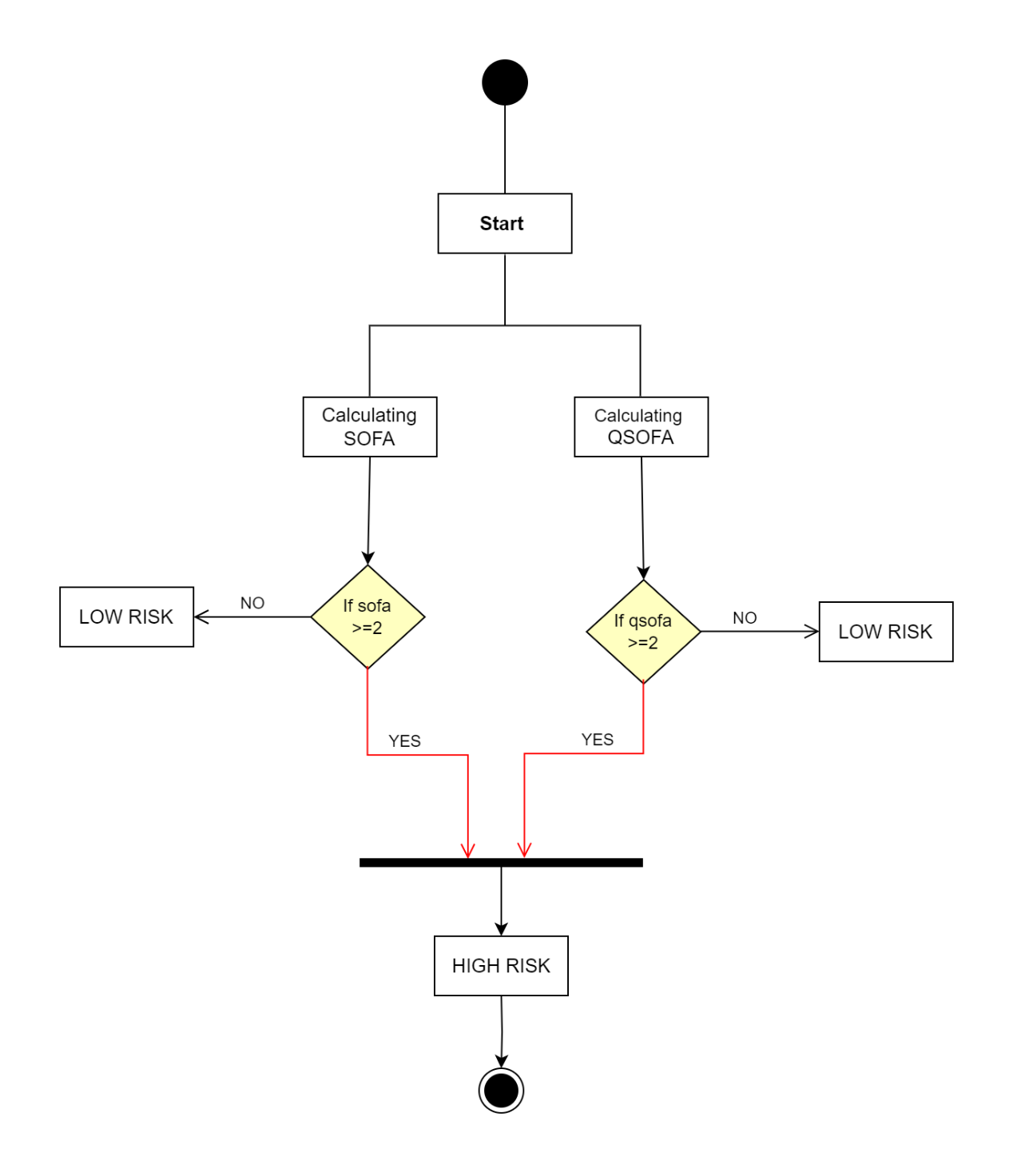

Fig 5.7 Activity Diagram

**CHAPTER 6**

**SYSTEM IMPLEMENTATION**

**6.1 Algorithm Style**

**6.1.1 Logistic Regression**

In our project, logistic regression can do various task like:

* **Predictive Modeling:** Logistic regression is a statistical method commonly used for binary classification problems, where the goal is to predict the presence of a particular condition, such as sepsis. In sepsis prediction, logistic regression can be used to build a predictive model that takes into account various patient-related factors and clinical data to estimate the likelihood of a patient developing sepsis during their ICU stay.
* **Feature Selection:** Logistic regression can help identify which patient variables or features are most relevant for predicting sepsis. This involves selecting and weighting various clinical and laboratory measurements, vital signs, and other patient data that are considered potential risk factors for sepsis.
* **Risk Stratification:** Logistic regression can help in stratifying patients into different risk categories based on their calculated sepsis risk scores. This can assist healthcare providers in prioritizing care and interventions for patients at higher risk of sepsis.

**6.2 Description of Detailed Methodologies**

**Data Acquisition and Preprocessing**:

The project begins by collecting healthcare data from a dataset sourced from Kaggle. This data is then preprocessed to handle class imbalances and ensure its suitability for predictive modeling.

**Predictive Modeling**:

In this project, we've chosen to begin with Logistic Regression as our primary model. We've fine-tuned it to improve early sepsis detection accuracy. Additionally, we plan to experiment with various other algorithms, such as Random Forest, Support Vector Machines. After evaluating their performance, we'll pick the best-performing model for sepsis detection. This approach helps us find the most suitable model for our dataset and the goal of early sepsis prediction.

**Web Interface**:

The project maintains a user-friendly web interface built with HTML and CSS, providing access to educational content and the predictive model. Users, including the general public and healthcare professionals, can access information on sepsis awareness, symptoms, and risk assessment.

**Flask Web Framework**:

The Flask web framework serves as the backbone of the digital platform. It handles user requests, routes them to the appropriate components, and ensures seamless communication between the user interface and the server.

**Interdisciplinary Collaboration**:

Effective collaboration between healthcare professionals, data scientists, web developers, and educators is pivotal. It ensures that the project combines expertise in medical practices, data analysis, web development, and educational content.

**Security and Privacy Compliance**:

The system adheres to stringent security and data privacy standards, safeguarding sensitive healthcare information and ensuring ethical data usage.

**CHAPTER 7**

**TEST CASES**

|  |  |  |  |  |
| --- | --- | --- | --- | --- |
| No. | Functional Test Cases | Actual Output | Expected Output | Test Status |
| 1 | Verify if the User is able to see the complete UI of the system. | The UI is visible. | The UI is visible. | Pass |
| 2 | Verify if the training model is giving good accuracy or not | Showed Accuracy of 74.5% | Should show accuracy of minimum 80% | Fail |

Table 7.1. Test case

**CHAPTER 8**

**PROPOSED GUI/WORKING MODULES/EXPERIMENTAL RESULTS**

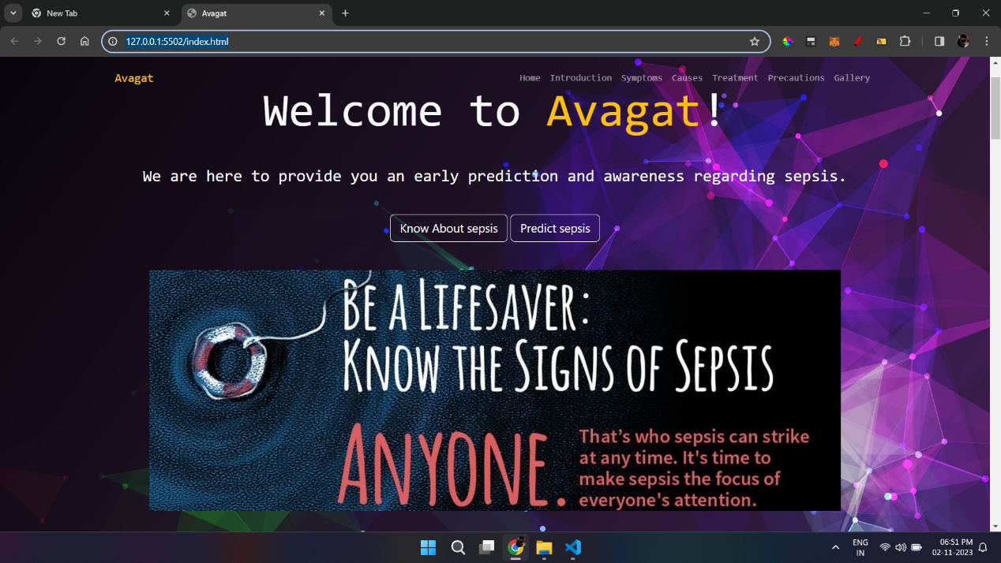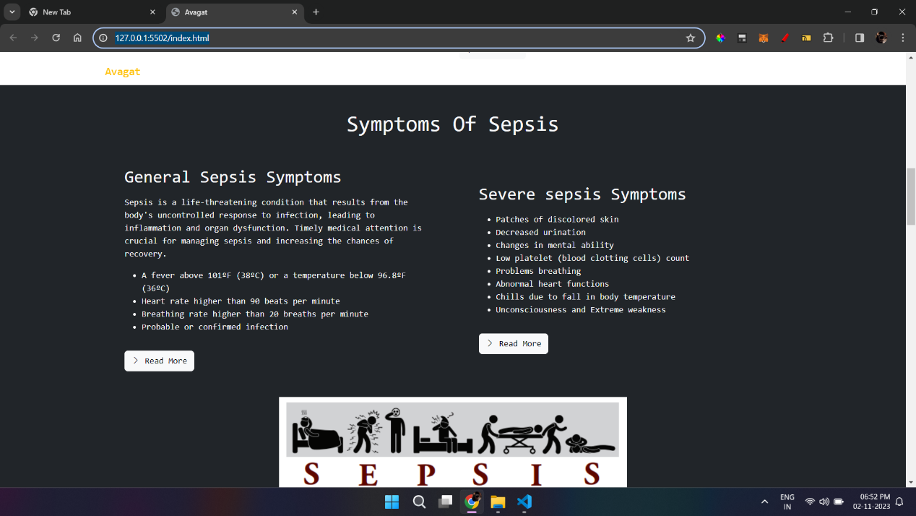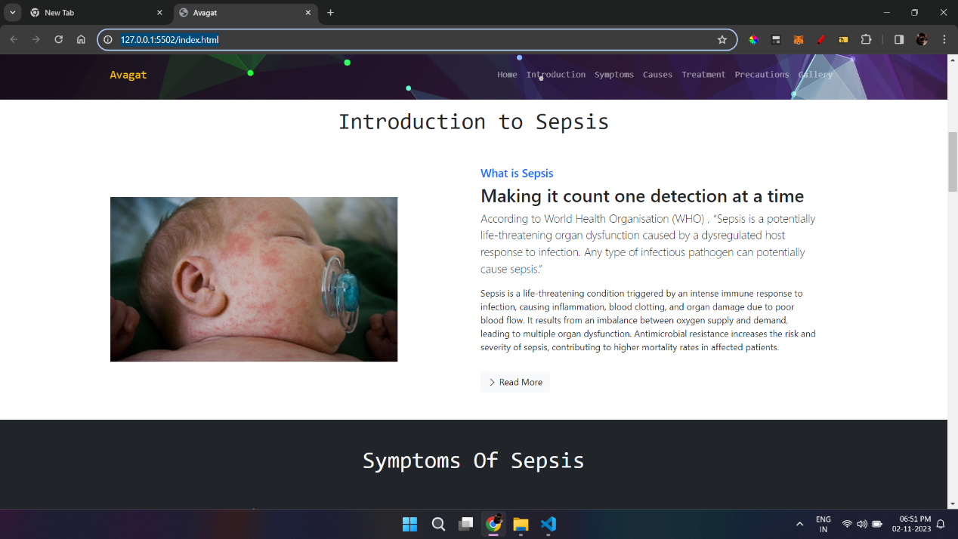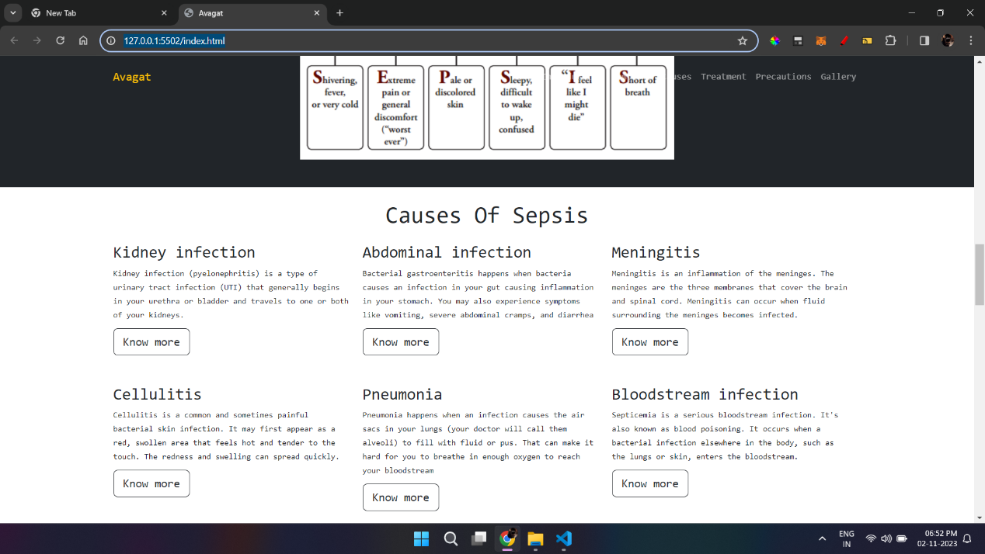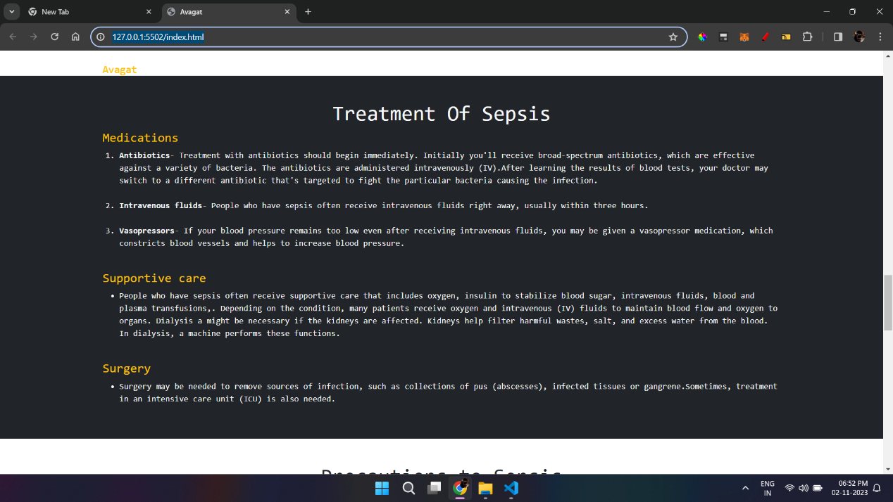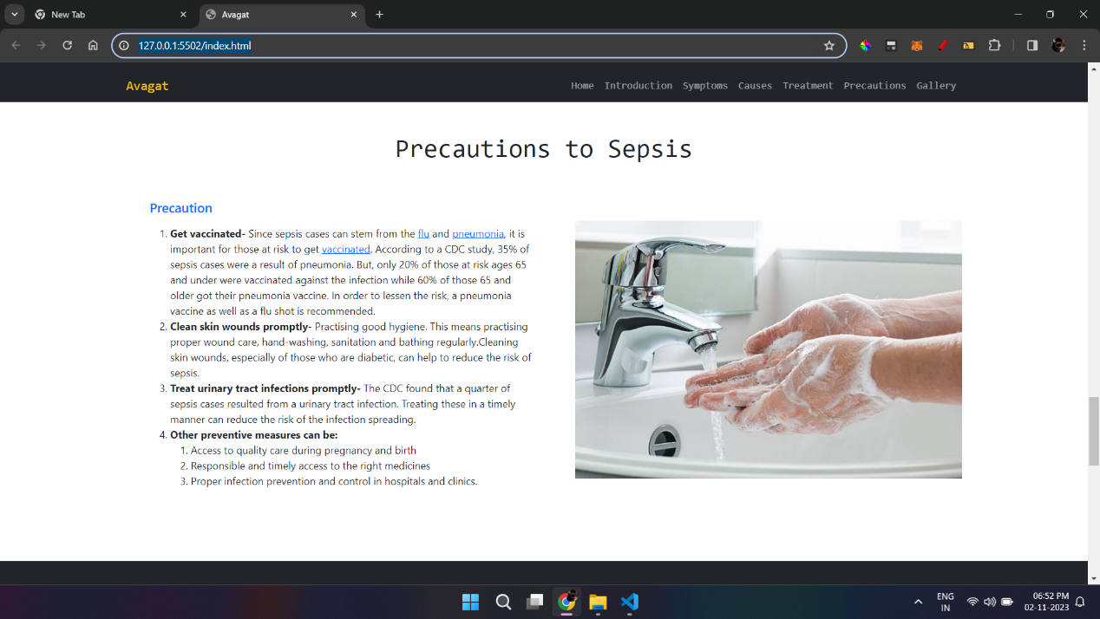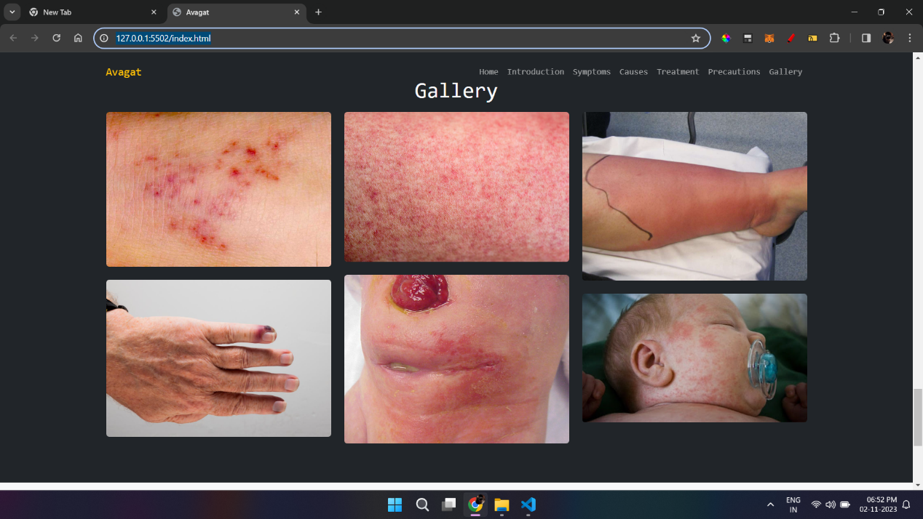

**CHAPTER 9**

**PROJECT PLAN**

|  |  |  |
| --- | --- | --- |
| Sr. no. | Tasks | Time taken |
| 1. | * Finalization of Domain and Project Title. * Decided precise Problem Statement based on the Literature Survey and Feasibility Study. | Week 1 |
| 2. | * Identification of gaps as per reference papers. * Identification of 4/5 major functionalities of the project. * Identification of Stakeholders, Actors, and Architectural Styles. | Week 2 |
| 3. | * Preparation of Review-1 | Week 3 |
| 4. | * Finalization of Motivation, Objectives, and Scope of the project. * Listed required Hardware, Software, or other equipment for executing the project. | Week 4 |
| 5. | * Done System overview- proposed system and expected outcomes. | Week 5 |
| 6. | * Finalization of Architecture and initial phase of design. | Week 6 |
| 7. | * Identification of User and System Requirements. * Identification of Functional and Non-functional Requirements. * Done Requirement Analysis / Models. | Week 7 |
| 8. | * UML Diagrams such as DFD (data flow diagrams), sequence diagram, activity diagram, use case diagram, class diagram, etc.) | Week 8 |
| 9. | * Detail architecture and System design. | Week 9 |
| 10. | * Identification of modules to be implemented later in project. | Week 10 |
| 11. | * Finalized Algorithms for each module. | Week 11 |
| 12. | * Identification of tests to be essential and appropriate (to be implemented later) | Week 12 |
| 13. | * Identification and participation in a project- related competition. | Week 13 |
| 14. | * Preparing Draft of Project Report Phase-1 | Week 14 |

**CHAPTER 10**

**CONCLUSION**

In conclusion, our project represents a pioneering endeavor that addresses the critical issues of sepsis awareness and early detection in intensive care units (ICUs). By integrating education, technology, and clinical insights, this project strives to create a holistic approach to sepsis management, with the ultimate goal of improving patient outcomes and reducing sepsis-related fatalities.

Through a user-friendly web interface and educational content, the project empowers individuals, both healthcare professionals and the general public, with the knowledge and tools to recognize sepsis symptoms early. This educational component, combined with the implementation of the Random Forest Regress or algorithm fine-tuned for accuracy, ensures rapid and accurate sepsis risk assessment.

The project's significance is underscored by the potential to save lives and contribute to a healthier future. By raising sepsis awareness, fostering early detection, and ensuring the ethical and secure handling of healthcare data, the project sets a precedent for the successful integration of education and technology in healthcare practices.

As we look ahead, the project not only holds the promise of reducing the burden of sepsis but also serves as a model for addressing critical medical conditions through interdisciplinary collaboration. With its commitment to improving patient-centered care, the project stands as a testament to the potential of innovation in healthcare, setting a course toward a brighter and healthier future for all.

**BIBLIOGRAPHY**

[1] Anurag Shankar, Mufaddal Diwan, Snigdha Singh, Husain Nahrpurawala and Tanusri Bhowmick, “Early Prediction of Sepsis using Machine Learning,” IEEE 2021.

[2] Guilan Kong, Ke Lin and Yonghua Hu,” Using machine learning methods to predict in-hospital mortality of sepsis patients in the ICU”, 2020, Published by

BMC.

[3] B. C. Srimedha, Rashmi Naveen Raj, And Veena Mayya, “A Comprehensive Machine Learning Based Pipeline for an Accurate Early Prediction of Sepsis in ICU”, IEEE access 2022.

[4] Yash Veer Singh, Pushpendra Singh, Shadab Khan, and Ram Sewak Singh,” A Machine Learning Model for Early Prediction and Detection of Sepsis in Intensive Care Unit Patients”, 2022, Published by Hindawi.

**APPENDIX A**

**PLAGIARISM REPORT**

**Plagiarism Report of Paper and Project report from any open-source tool.**

The report should indicate 90% uniqueness. Online plagiarism checking tools may be used.